2. What is a Spring Framework?
- Spring is a powerful open source, application framework created to reduce the complexity of enterprise application development.
- It is light-weighted and loosely coupled.
- It has layered architecture, which allows you to select the components to use, while also providing a cohesive framework for J2EE application development.
- Spring framework is also called the framework of frameworks as it provides support to various other frameworks such as Struts, Hibernate, Tapestry, EJB, JSF etc.

3. List the advantages of Spring Framework.
- Because of Spring Frameworks layered architecture, you can use what you need and leave which you don’t.
- Spring Framework enables POJO (Plain Old Java Object) Programming which in turn enables continuous integration and testability.
- JDBC is simplified due to Dependency Injection and Inversion of Control.
- It is open-source and has no vendor lock-in.

4. What are the different features of Spring Framework?
Following are some of the major features of Spring Framework :
- Lightweight: Spring is lightweight when it comes to size and transparency.
- Inversion of control (IOC): The objects give their dependencies instead of creating or looking for dependent objects. This is called Inversion Of Control.
- Aspect oriented Programming (AOP): Aspect oriented programming in Spring supports cohesive development by separating application business logic from system services.
- Container: Spring Framework creates and manages the life cycle and configuration of the application objects.
- MVC Framework: Spring Framework’s MVC web application framework is highly configurable. Other frameworks can also be used easily instead of Spring MVC Framework.
- Transaction Management: Generic abstraction layer for transaction management is provided by the Spring Framework. Spring’s transaction support can be also used in container less environments.
- JDBC Exception Handling: The JDBC abstraction layer of the Spring offers an exception hierarchy, which simplifies the error handling strategy.

5. How many modules are there in Spring Framework and what are they?
There are around 20 modules which are generalized into Core Container, Data Access/Integration, Web, AOP (Aspect Oriented Programming), Instrumentation and Test.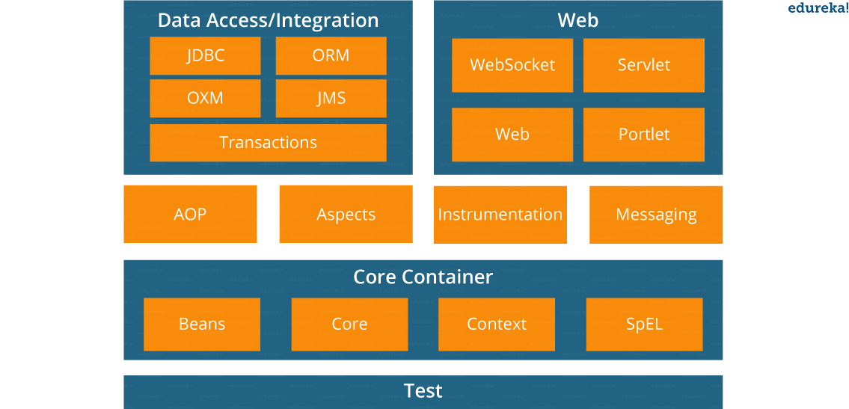
- Spring Core Container – This layer is basically the core of Spring Framework. It contains the following modules :
- Spring Core
- Spring Bean
- SpEL (Spring Expression Language)
- Spring Context
- Data Access/Integration – This layer provides support to interact with the database. It contains the following modules :
- JDBC (Java DataBase Connectivity)
- ORM (Object Relational Mapping)
- OXM (Object XML Mappers)
- JMS (Java Messaging Service)
- Transaction
- Web – This layer provides support to create web application. It contains the following modules :
- Web
- Web – MVC
- Web – Socket
- Web – Portlet
- Aspect Oriented Programming (AOP) – In this layer you can use Advices, Pointcuts etc., to decouplethe code.
- Instrumentation – This layer provides support to class instrumentation and classloader implementations.
- Test – This layer provides support to testing with JUnit and TestNG.
Few Miscellaneous modules are given below:
- Messaging – This module provides support for STOMP. It also supports an annotation programming model that is used for routing and processing STOMP messages from WebSocket clients.
- Aspects – This module provides support to integration with AspectJ.

6. What is a Spring configuration file?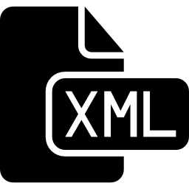
A Spring configuration file is an XML file. This file mainly contains the classes information. It describes how those classes are configured as well as introduced to each other. The XML configuration files, however, are verbose and more clean. If it’s not planned and written correctly, it becomes very difficult to manage in big projects.

7. What are the different components of a Spring application?
A Spring application, generally consists of following components:
- Interface: It defines the functions.
- Bean class: It contains properties, its setter and getter methods, functions etc.
- Spring Aspect Oriented Programming (AOP): Provides the functionality of cross-cutting concerns.
- Bean Configuration File: Contains the information of classes and how to configure them.
- User program: It uses the function.

8. What are the various ways of using Spring Framework?
Spring Framework can be used in various ways. They are listed as follows:
- As a Full-fledged Spring web application.
- As a third-party web framework, using Spring Frameworks middle-tier.
- For remote usage.
- As Enterprise Java Bean which can wrap existing POJOs (Plain Old Java Objects).
The next section of Spring Interview Questions is on Dependency Injection and IoC container.

Dependency Injection/ IoC Container – Spring Interview Questions

9. What is Spring IOC Container?

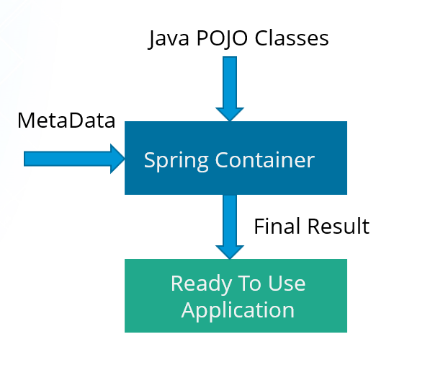
At the core of the Spring Framework, lies the Spring container. The container creates the object, wires them together, configures them and manages their complete life cycle. The Spring container makes use of Dependency Injection to manage the components that make up an application. The container receives instructions for which objects to instantiate, configure, and assemble by reading the configuration metadata provided. This metadata can be provided either by XML, Java annotations or Java code.

10. What do you mean by Dependency Injection?
In Dependency Injection, you do not have to create your objects but have to describe how they should be created. You don’t connect your components and services together in the code directly, but describe which services are needed by which components in the configuration file. The IoC container will wire them up together.

Inversion Of Control (IOC) and Dependency Injection
These are the design patterns that are used to remove dependency from the programming code. They make the code easier to test and maintain. Let's understand this with the following code:
- class Employee{
- Address address;
- Employee(){
- address=new Address();
- }
- }
In such case, there is dependency between the Employee and Address (tight coupling). In the Inversion of Control scenario, we do this something like this:
- class Employee{
- Address address;
- Employee(Address address){
- this.address=address;
- }
- }
Thus, IOC makes the code loosely coupled. In such case, there is no need to modify the code if our logic is moved to new environment.
In Spring framework, IOC container is responsible to inject the dependency. We provide metadata to the IOC container either by XML file or annotation.

11. In how many ways can Dependency Injection be done?
In general, dependency injection can be done in three ways, namely :
- Constructor Injection
- Setter Injection
- Interface Injection

3. Dependency Injection Example?
Dependency injection is a pattern through which to implement IoC, where the control being inverted is the setting of object’s dependencies.
The act of connecting objects with other objects, or “injecting” objects into other objects, is done by an assembler rather than by the objects themselves.
Here’s how you would create an object dependency in traditional programming:
1  2  3  4  5  6  7 | public class Store {  private Item item;  public Store() {  item = new ItemImpl1();  }  }
In the example above, we need to instantiate an implementation of the Item interface within the Storeclass itself.
By using DI, we can rewrite the example without specifying the implementation of Item that we want:
1  2  3  4  5  6 | public class Store {  private Item item;  public Store(Item item) {  this.item = item;  }  }
In the next sections, we’ll see how we can provide the implementation of Item through metadata.
Both IoC and DI are simple concepts, but have deep implications in the way we structure our systems, so they’re well worth understanding well.

4. The Spring IoC Container
The IoC container is responsible to instantiate, configure and assemble the objects. The IoC container gets informations from the XML file and works accordingly. The main tasks performed by IoC container are:
- to instantiate the application class
- to configure the object
- to assemble the dependencies between the objects
There are two types of IoC containers. They are:
- BeanFactory
- ApplicationContext

12. Differentiate between constructor injection and setter injection.

Constructor Injection vs Setter Injection
Constructor Injection | Setter Injection
There is no partial injection. | There can be partial injection.
It doesn’t override the setter property. | It overrides the constructor property.
It will create a new instance if any modification is done. | It will not create new instance if any modification is done.
It works better for many properties. | It works better for few properties.

13. How many types of IOC containers are there in spring?
- BeanFactory: BeanFactory is like a factory class that contains a collection of beans. It instantiates the bean whenever asked for by clients.
- ApplicationContext: The ApplicationContext interface is built on top of the BeanFactory interface. It provides some extra functionality on top BeanFactory.
The most commonly used ApplicationContext implementations are −
  - FileSystemXmlApplicationContext − This container loads the definitions of the beans from an XML file. Here you need to provide the full path of the XML bean configuration file to the constructor.
  - ClassPathXmlApplicationContext − This container loads the definitions of the beans from an XML file. Here you do not need to provide the full path of the XML file but you need to set CLASSPATH properly because this container will look like bean configuration XML file in CLASSPATH.
  - WebXmlApplicationContext − This container loads the XML file with definitions of all beans from within a web application.

14. Differentiate between BeanFactory and ApplicationContext.

BeanFactory vs ApplicationContext
BeanFactory | ApplicationContext
It is an interface defined in org.springframework.beans.factory.BeanFactory  Resource resource=new ClassPathResource("applicationContext.xml");  BeanFactory factory=new XmlBeanFactory(resource);  Student student=(Student)factory.getBean("studentbean");  student.displayInfo(); | It is an interface defined in org.springframework.context.ApplicationContext  ApplicationContext context =  new ClassPathXmlApplicationContext("applicationContext.xml");  Student student=(Student)context.getBean("studentbean");  student.displayInfo();
It uses Lazy initialization | It uses Eager/ Aggressive initialization
It explicitly provides a resource object using the syntax | It creates and manages resource objects on its own
It doesn’t supports internationalization | It supports internationalization
It doesn’t supports annotation based dependency | It supports annotation based dependency

15. List some of the benefits of IoC.
Some of the benefits of IoC are:
- It will minimize the amount of code in your application.
- It will make your application easy to test because it doesn’t require any singletons or JNDI lookup mechanisms in your unit test cases.
- It promotes loose coupling with minimal effort and least intrusive mechanism.
- It supports eager instantiation and lazy loading of the services.
Let’s move on to the next section of Spring Interview Questions, that is Spring Beans Interview Questions.

Spring Beans – Spring Interview Questions

16. Explain Spring Beans?
- They are the objects that form the backbone of the user’s application.
- Beans are managed by the Spring IoC container.
- They are instantiated, configured, wired and managed by a Spring IoC container
- Beans are created with the configuration metadata that the users supply to the container.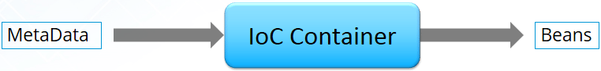

17. How configuration metadata is provided to the Spring container?
Configuration metadata can be provided to Spring container in following ways:
- XML-Based configuration: In Spring Framework, the dependencies and the services needed by beans are specified in configuration files which are in XML format. These configuration files usually contain a lot of bean definitions and application specific configuration options. They generally start with a bean tag. For example:
1  2  3 | <bean id="studentbean" class="org.edureka.firstSpring.StudentBean">  <property name="name" value="Edureka"></property>  </bean>
- Annotation-Based configuration: Instead of using XML to describe a bean wiring, you can configure the bean into the component class itself by using annotations on the relevant class, method, or field declaration. By default, annotation wiring is not turned on in the Spring container. So, you need to enable it in your Spring configuration file before using it. For example:
1  2  3  4 | <beans>  <context:annotation-config/>  <!-- bean definitions go here -->  </beans>
- Java-based configuration: The key features in Spring Framework’s new Java-configuration support are @Configuration annotated classes and @Bean annotated methods.
1. @Bean annotation plays the same role as the <bean/> element.
2.@Configuration classes allows to define inter-bean dependencies by simply calling other @Bean methods in the same class.
For example:
1  2  3  4  5  6  7 | @Configuration  public class StudentConfig  {  @Bean  public StudentBean myStudent()  { return new StudentBean(); }  }

18. How many bean scopes are supported by Spring?
The Spring Framework supports five scopes. They are:
- Singleton: This provides scope for the bean definition to single instance per Spring IoC container.
- Prototype: This provides scope for a single bean definition to have any number of object instances.
- Request: This provides scope for a bean definition to an HTTP-request.
- Session: This provides scope for a bean definition to an HTTP-session.
- Global-session: This provides scope for a bean definition to an Global HTTP-session.
The last three are available only if the users use a web-aware ApplicationContext.

19. What is the Bean life cycle in Spring Bean Factory Container?
Bean life cycle in Spring Bean Factory Container is as follows:
- The Spring container instantiates the bean from the bean’s definition in the XML file.
- Spring populates all of the properties using the dependency injection, as specified in the bean definition.
- The factory calls setBeanName() by passing the bean’s ID, if the bean implements the BeanNameAware interface.
- The factory calls setBeanFactory() by passing an instance of itself, if the bean implements the BeanFactoryAware interface.
- preProcessBeforeInitialization() methods are called if there are any BeanPostProcessors associated with the bean.
- If an init-method is specified for the bean, then it will be called.
- Finally, postProcessAfterInitialization() methods will be called if there are any BeanPostProcessors associated with the bean.
To understand it in better way check the below diagram:
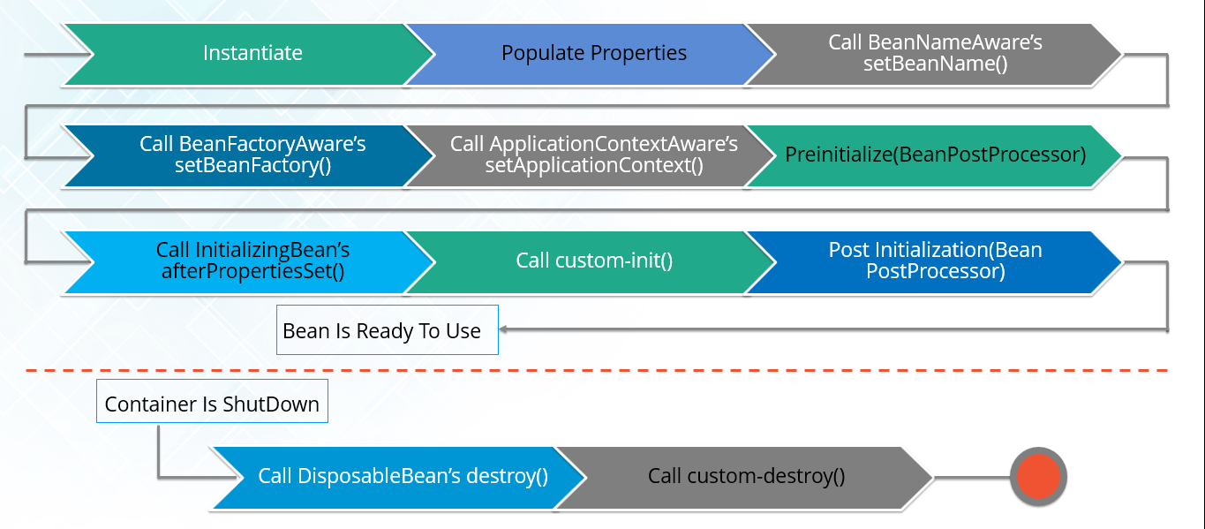

Dependency Injection in Spring can be done through constructors, setters or fields.

5. Constructor-Based Dependency Injection
In the case of constructor-based dependency injection, the container will invoke a constructor with arguments each representing a dependency we want to set.
Spring resolves each argument primarily by type, followed by name of the attribute and index for disambiguation. Let’s see the configuration of a bean and its dependencies using annotations:
1  2  3  4  5  6  7  8  9  10  11  12  13 | @Configuration  public class AppConfig {  @Bean  public Item item1() {  return new ItemImpl1();  }  @Bean  public Store store() {  return new Store(item1());  }  }
The @Configuration annotation indicates that the class is a source of bean definitions. Also, we can add it to multiple configuration classes.
The @Bean annotation is used on a method to define a bean. If we don’t specify a custom name, the bean name will default to the method name.
For a bean with the default singleton scope, Spring first checks if a cached instance of the bean already exists and only creates a new one if it doesn’t. If we’re using the prototype scope, the container returns a new bean instance for each method call.
Another way to create the configuration of the beans is through XML configuration:
1  2  3  4 | <bean id="item1" class="org.baeldung.store.ItemImpl1" />  <bean id="store" class="org.baeldung.store.Store">  <constructor-arg type="ItemImpl1" index="0" name="item" ref="item1" />  </bean>

6. Setter-Based Dependency Injection
For setter-based DI, the container will call setter methods of our class, after invoking a no-argument constructor or no-argument static factory method to instantiate the bean. Let’s create this configuration using annotations:
1  2  3  4  5  6 | @Bean  public Store store() {  Store store = new Store();  store.setItem(item1());  return store;  }
We can also use XML for the same configuration of beans:
1  2  3 | <bean id="store" class="org.baeldung.store.Store">  <property name="item" ref="item1" />  </bean>
Constructor-based and setter-based types of injection can be combined for the same bean. The Spring documentation recommends using constructor-based injection for mandatory dependencies, and setter-based injection for optional ones.

7. Field-Based Dependency Injection
In case of Field-Based DI, we can inject the dependencies by marking them with an @Autowiredannotation:
1  2  3  4 | public class Store {  @Autowired  private Item item;  }
While constructing the Store object, if there’s no constructor or setter method to inject the Item bean, the container will use reflection to inject Item into Store.
We can also achieve this using XML configuration.
This approach might look simpler and cleaner but is not recommended to use because it has a few drawbacks such as:
- This method uses reflection to inject the dependencies, which is costlier than constructor-based or setter-based injection
- It’s really easy to keep adding multiple dependencies using this approach. If you were using constructor injection having multiple arguments would have made us think that the class does more than one thing which can violate the Single Responsibility Principle.
More information on @Autowired annotation can be found in Wiring In Spring article.

8. Autowiring Dependencies
Wiring allows the Spring container to automatically resolve dependencies between collaborating beans by inspecting the beans that have been defined.
There are four modes of autowiring a bean using an XML configuration:
- no: the default value – this means no autowiring is used for the bean and we have to explicitly name the dependencies
- byName: autowiring is done based on the name of the property, therefore Spring will look for a bean with the same name as the property that needs to be set
- byType: similar to the byName autowiring, only based on the type of the property. This means Spring will look for a bean with the same type of the property to set. If there’s more than one bean of that type, the framework throws an exception.
- constructor: autowiring is done based on constructor arguments, meaning Spring will look for beans with the same type as the constructor arguments
For example, let’s autowire the item1 bean defined above by type into the store bean:
1  2  3  4  5  6  7  8  9 | @Bean(autowire = Autowire.BY_TYPE)  public class Store {  private Item item;  public setItem(Item item){  this.item = item;  }  }
We can also inject beans using the @Autowired annotation for autowiring by type:
1  2  3  4  5 | public class Store {  @Autowired  private Item item;  }
If there’s more than one bean of the same type, we can use the @Qualifier annotation to reference a bean by name:
1  2  3  4  5  6 | public class Store {  @Autowired  @Qualifier("item1")  private Item item;  }
Now, let’s autowire beans by type through XML configuration:
1 | <bean id="store" class="org.baeldung.store.Store" autowire="byType"> </bean>
Next, let’s inject a bean named item into the item property of store bean by name through XML:
1  2  3  4 | <bean id="item" class="org.baeldung.store.ItemImpl1" />  <bean id="store" class="org.baeldung.store.Store" autowire="byName">  </bean>
We can also override the autowiring by defining dependencies explicitly through constructor arguments or setters.

9. Lazy Initialized Beans
By default, the container creates and configures all singleton beans during initialization. To avoid this, you can use the lazy-init attribute with value true on the bean configuration:
1 | <bean id="item1" class="org.baeldung.store.ItemImpl1" lazy-init="true" />

MVC (Model-View-Controller) – Spring Interview Questions

47. What do you mean by Spring MVC framework?
The Spring web MVC framework provides model-view-controller architecture and ready to use components that are used to develop flexible and loosely coupled web applications. The MVC pattern helps in separating the different aspects of the application like input logic, business logic and UI logic, while providing a loose coupling between all these elements.

48. Describe DispatcherServlet.
The DispatcherServlet is the core of Spring Web MVC framework. It handles all the HTTP requests and responses. The DispatcherServlet receives the entry of handler mapping from the configuration file and forwards the request to the controller. The controller then returns an object of Model And View. The DispatcherServlet checks the entry of view resolver in the configuration file and calls the specified view component.
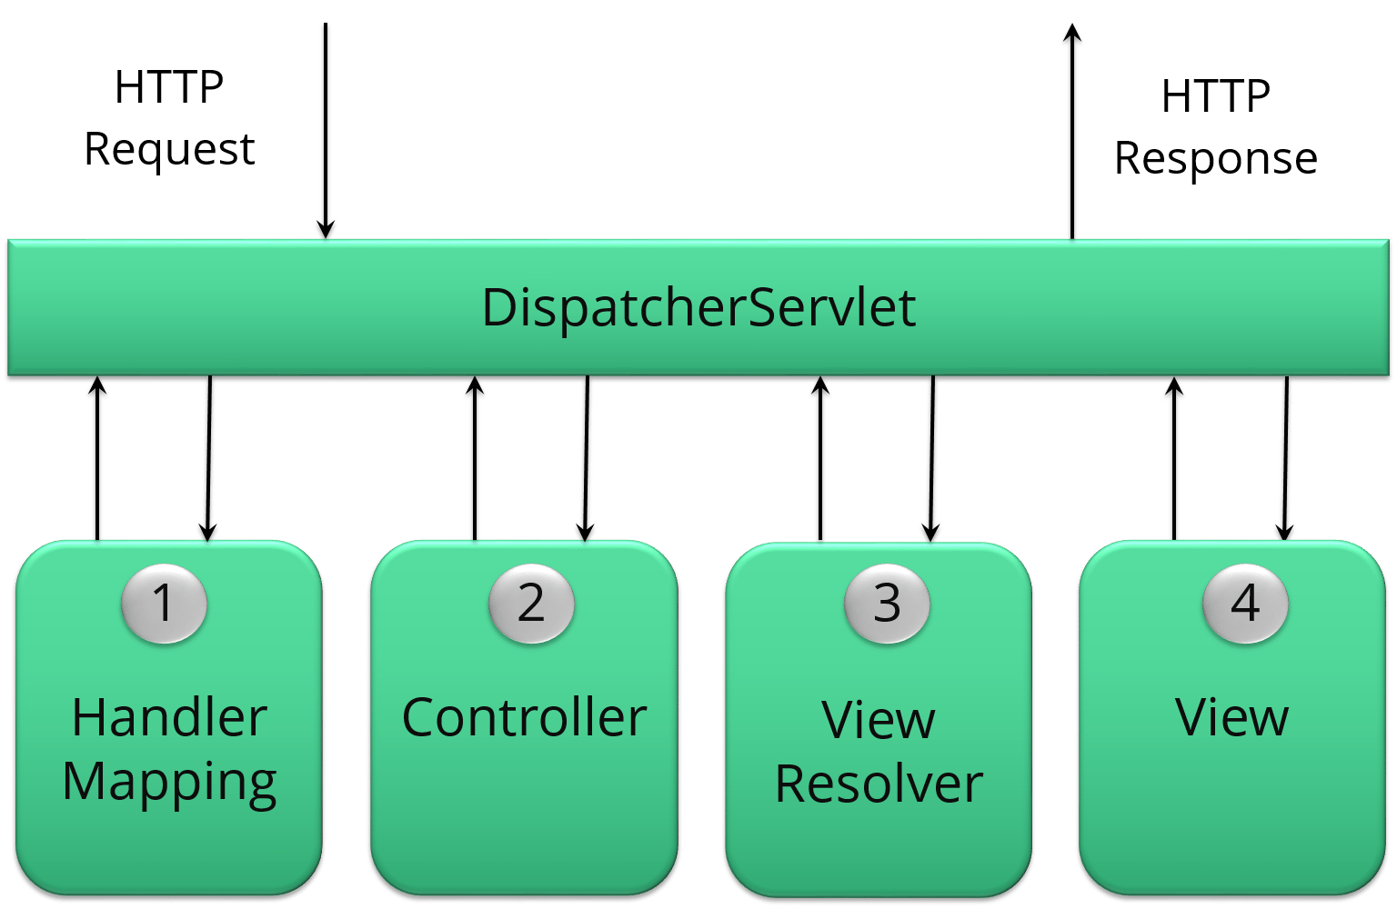

49. Explain WebApplicationContext.
The WebApplicationContext is an extension of the plain ApplicationContext. It has some extra features that are necessary for web applications. It differs from a normal ApplicationContext in terms of its capability of resolving themes and in deciding which servlet it is associated with.

50. In Spring MVC framework, what is controller?
Controllers provide access to the application behaviour. These behaviours are generally defined through a service interface. Controllers interpret the user input and transform it into a model which is represented to the user by the view. In Spring, controller is implemented in a very abstract way. It also enables you to create a wide variety of controllers.
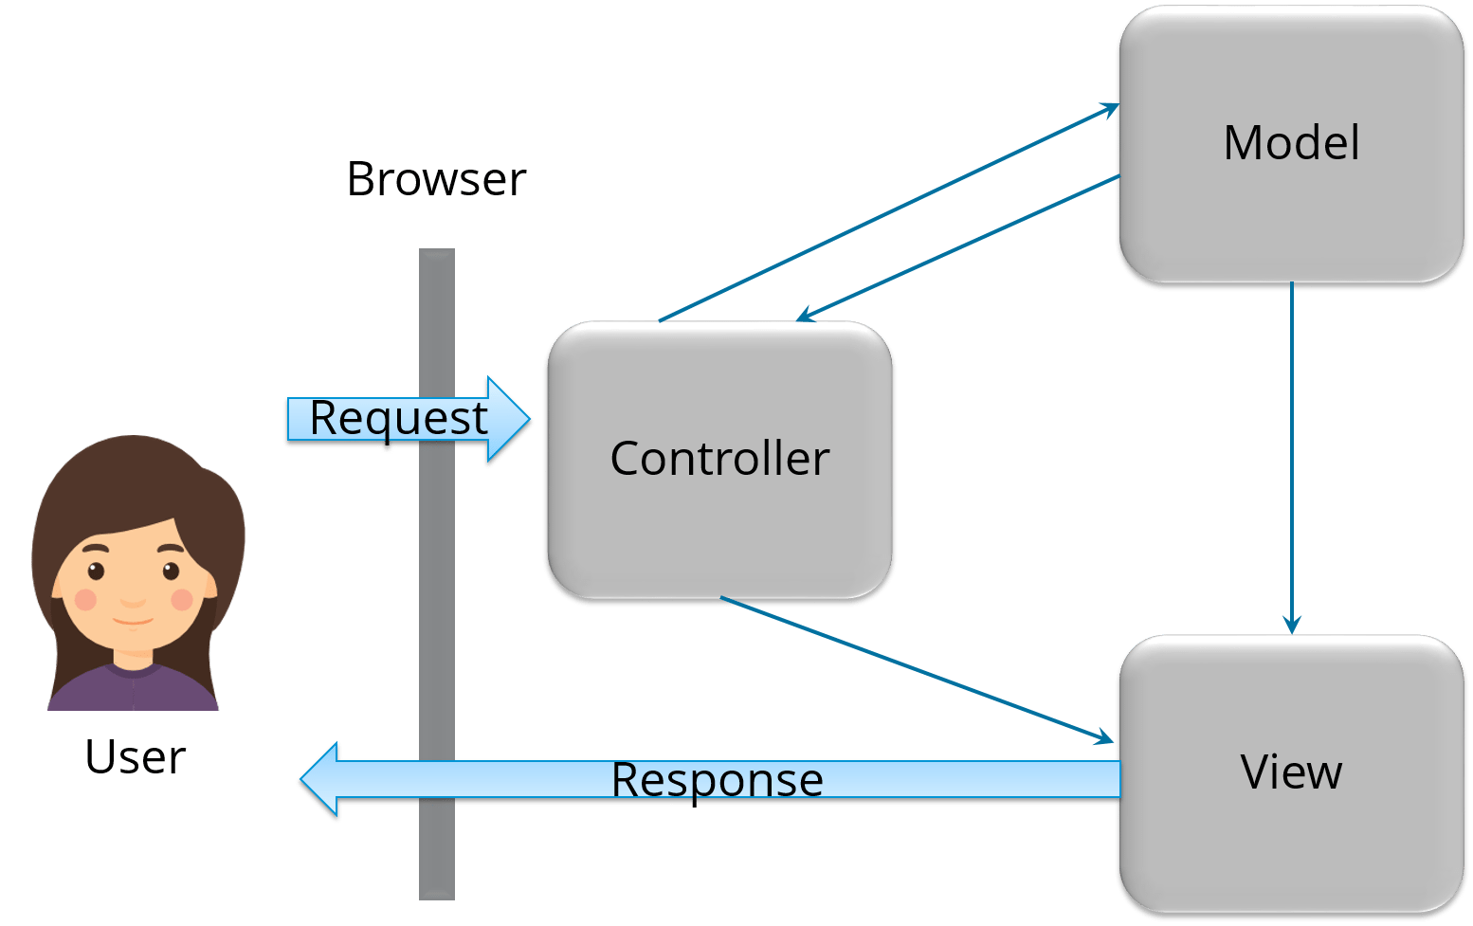

<bean id="ans1" class="com.javatpoint.Answer">
<constructor-arg value="1"></constructor-arg>
<constructor-arg value="Java is a programming language"></constructor-arg>
<constructor-arg value="John"></constructor-arg>
</bean>

<constructor-arg>
<list>
<ref bean="ans1"/>
<ref bean="ans2"/>
</list>
</constructor-arg>

<constructor-arg>
<map>
<entry key="Java is a Programming Language" value="Ajay Kumar"></entry>
<entry key="Java is a Platform" value="John Smith"></entry>
<entry key="Java is an Island" value="Raj Kumar"></entry>
</map>
</constructor-arg>

<bean id="obj" class="com.javatpoint.Employee">
<property name="id" value="1"></property>
<property name="name" value="Sachin Yadav"></property>
<property name="address" ref="address1"></property>
</bean>
<map>
<entry key-ref="answer1" value-ref="user1"></entry>
<entry key-ref="answer2" value-ref="user2"></entry>
</map>

SOAP VS REST (WHY COMPARING THEM IS A NONSENSE)
I know you won’t like this answer… But SOAP vs REST is not the right question to ask. Rest, unlike Soap, is an architectural style, not a protocol. To better understand REST, one should read RESTful Design Principles.
Okay, but Why do some people like SOAP while others love REST? Why is there such a strong emotion around those two names?
Because the best way to compare things is to compare them point by point, we have created a huge table which compares Soap to Rest with 10+ different criterias.

Comparison Table
The following table lists all the key differences between those two protocols:
# | SOAP | REST
On API Changes | Client code must be recompiled with new WSDL | Can be backward compatible
Asynchronous | Yes, Asynchronous Messaging | Synchronous
Bandwidth Usage | +++ | +
Cacheable | No | Yes
Data Formats | Only XML | XML, Json, Plain Text, etc
Definition | WSDL Defines the endpoints exposed by the service | Uses XML or JSON to send and receive data
Documentation | The SOAP protocol can be quite difficult to understand (many options), but well documented. | Depends on the documentation provided by the service designer (Swagger for example)
Error Handling | Built-in | No error handling
Exposed Business Logic | Services Interfaces | URIs
Failure Handling | Retry logic built-in | Expects Client to retry
Goal | Focuses on exposing pieces of application logic (not data) as services | Focuses on accessing named resources through a single consistent interface
Invokation | Invokes Services by calling RPC Methods | Simply call services using HTTP Requests
Java API | JAX-WS | Jax-RS
Javascript Support | Difficult | Easy
Network | Transfer over HTTP, SMTP, FTP etc. | Purely HTTP
Official Standard | Yes | No
Statefullness | Supports stateless and stateful operations | Emphasizes stateless communication
Payload | XML Soap Envelop, must comply Soap schema | Can be any format
Payload Constraints | Must support XML Serialization
Performance | Depends on Message Encryption, Signing etc. Typically lower than Rest | Almost no protocol overhead.
Protocol | XML Based Message Protocol | A Free architectural Style Protocol
Reliability | Reliable | Not Reliable, an HTTP Delete can return OK even if it did not work
Security | Supports SSL, but also WS-Security (XML Encryption and Signature) | Depends on the documentation provided by the service designer (Swagger for example)
Time to Market | Slow | Fast
Tooling | Requires significant middleware tooling support | Only HTTP support is required
Who uses it? | Financial, Payment Gateways, Telecommunication | Social Media, Web, Mobile

Examples

SOAP
SOAP is the standard messaging protocol used by Web Services. SOAP’s primary goal is inter application communication. SOAP codifies the use of XML as an encoding scheme for request and response parameters using HTTP as a mean of transport.
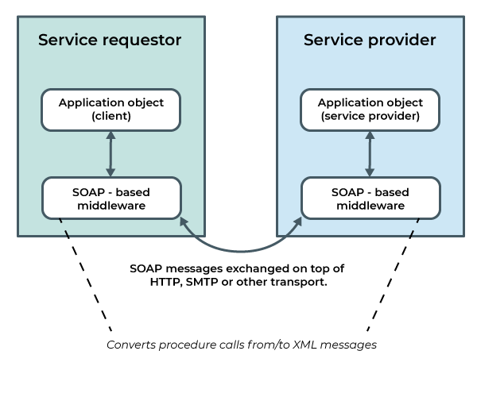
Here is an example of a SOAP request:

POST /InStock HTTP/1.1
Host: www.example.org
Content-Type: application/soap+xml; charset=utf-8
Content-Length: nnn

<?xml version="1.0"?>

<soap:Envelope
xmlns:soap="http://www.w3.org/2003/05/soap-envelope/"
soap:encodingStyle="http://www.w3.org/2003/05/soap-encoding">

<soap:Body xmlns:m="http://www.example.org/stock">
<m:GetStockPrice>
<m:StockName>IBM</m:StockName>
</m:GetStockPrice>
</soap:Body>

</soap:Envelope>
And the response returned by the server:
HTTP/1.1 200 OK
Content-Type: application/soap+xml; charset=utf-8
Content-Length: nnn

<?xml version="1.0"?>

<soap:Envelope
xmlns:soap="http://www.w3.org/2003/05/soap-envelope/"
soap:encodingStyle="http://www.w3.org/2003/05/soap-encoding">

<soap:Body xmlns:m="http://www.example.org/stock">
<m:GetStockPriceResponse>
<m:Price>34.5</m:Price>
</m:GetStockPriceResponse>
</soap:Body>

</soap:Envelope>
In this example the SOAP request has been sent through HTTP. But it could have been sent through any other network protocol too.
Here is the associated WSDL (document which describes the SOAP endpoints):
<?xml version=”1.0”?>
<definitions>
<message name="GetStockPriceRequest">
<part name="StockName" type="xs:string"/>
</message>
<message name="GetStockPriceResponse">
<part name="Price" type="xs:string"/>
</message>
<portType name="StockPrices">
<operation name="GetStockPrice">
<input message="GetStockPriceRequest"/>
<output message="GetStockPriceResponse"/>
</operation>
</portType>
</definitions>

The WSDL document defines the API endpoints exposed by the SOAP service thoroughly. But, it’s a common misunderstanding that WSDL are required for a SOAP service.
WSDL have been added later to the SOAP protocol. This is why the WSDL is optional. They have been added to help understand a web service endpoints. It’s quite difficult to know how to call a SOAP web-service without its WSDL definition.
The WSDL has also other benefits:
- Standard way to describe the service endpoints,
- There are tools to generate the code to call the service endpoints in almost any language,
- Most API testing tools supporting SOAP can automatically generate a test suite using a WSDL Definition.

REST
REST is a new and improved form of web services introduced as SOAP is complex. There isn’t a standard for REST architectures. REST exposes directory structure-like URIs. It is used to expose a public API over the Internet to handle CRUD operations on data.
REST works on Nouns, Verbs and Content Types:
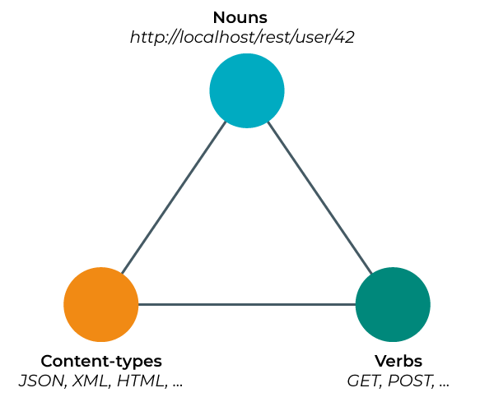
REST is all about sending HTTP request to specific endpoints and receiving data as a response. Here is an example REST HTTP Request:

GET /articles?include=author HTTP/1.1

Ànd the associated Json response:

HTTP/1.1 200 OK
Content-Type: application/vnd.api+json

{
"data": [{
"type": "articles",
"id": "1",
"attributes": {
"title": "JSON API paints my bikeshed!",
"body": "The shortest article. Ever.",
},
"relationships": {
"author": {
"data": {"id": "42", "type": "people"}
}
}
}],
"included": [
{
"type": "people",
"id": "42",
"attributes": {
"name": "John",
"age": 80,
"gender": "male"
}
}
]
}

REST stands for Representational State Transfer.
It mostly relies on a software architecture based on the stateless network protocol, known as HTTP (Hyper Text Transfer Protocol). REST can rely on many different data structures like JSON, XML, YML and more. Most Rest APIs are based on human-readable protocols (although there are binary protocols too, like the one Oracle Forms uses).
Json is the most widely used payload data structure as of now. While SOAP is strongly function oriented, REST is mostly data driven. It means Rest is mostly designed to get / put data, while SOAP is mostly designed as an RPC (Remote Procedure Call).

State of the Debate
There used to be a lot of debate around SOAP versus REST—“there’s no right answer” or “it’s all about priorities, personal preference.” It’s been about 15 years since REST was initially proposed by Roy Thomas Fielding (wiki) and a lot of the articles that say REST is the “new kid on the block” and “ever-gaining in popularity” are ten-plus years old.
The debate around SOAP and REST has been soaring for several years. Is it really worth it? From our point of view, both have strengths and weaknesses. It really depends on your project needs.
While REST has taken the fold over SOAP in the last 10 years, SOAP is still used for mission critical APIs. In fact, SOAP is best suited for long-hawl projects with strong emphasis on security and reliability. On the other side, Rest is best suited for projects with strong emphasis on simplicity and performance.

Rest Benefits
Here are all the benefits we see using Rest:
- Standard HTTP communication which traverses most firewalls with ease,
- REST is easier to scale: reads can be cached,
- Large Developers community, and many public facing apis using it,
- Lightweight because there is no protocol overhead,
- It works with both XML and Json, or whatever format you would like to use (including esoteric binary encrypted protocols),
- Javascript Friendly: executing HTTP requests is natively supported, especially with Json payloads,
- Faster Time to Market: Rest has free standards, letting you implement the logic between your client and server as you wish.
REST is generally preferred by small to medium organisation who have lower requirements on security. Simplicity is also often an argument in favor of REST when dealing with public APIs.

SOAP Benefits
Here are all the benefits we see using SOAP:
- Strong emphasis on standards: SOAP has an official standard which you must comply to,
- Best suited for large Enterprise projects, simply because it has a number of features like XML encryption, automatic retry on failure etc,
- Security is first class citizen, with built-in security features to protect messages from being corrupted,
- W3C standard,
- Comments and Embedded documentation supported,
- Service definition via a standard WSDL document,
- Best suited for stateful communications,
- Supports many transport protocols including HTTP, SMTP, plain sockets and more,
- SOAP’s standard HTTP protocol makes it easier for it to operate across firewalls and proxies. But, because it uses the complex XML format, it tends to be slower compared to middleware such as ICEand CORBA,
- And ACID-compliant Transactions.
SOAP is still used in many big organisations. With built-in security and reliability functions, SOAP is a great choice for applications where security is more critical than performance. SOAP is highly extensible. In addition to WS-Security, SOAP supports WS-Addressing, WS-Coordination, WS-ReliableMessaging, and a host of other web services standards, a full list of which you can find on W3C.

WS-Security
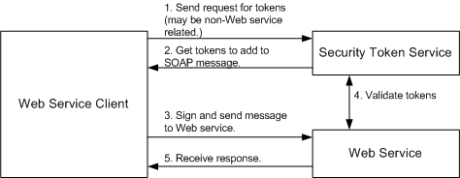
While SOAP supports SSL (just like REST) it also supports WS-Security. Supports identity through intermediaries, not just point to point (SSL). It also provides a standard implementation of data integrity and data privacy. Calling it Enterprise isn’t to say it’s more secure, it simply supports some security tools that typical internet services have no need for.
This protocol is about achieving end-to-end security by using encryption and cryptographic signing. Messages may pass through intermediaries of lower trust without risks. To be honest, an encrypted transport channel would do much better all the way from one endpoint to the other: This is called SSL (Secure Socket Layer).
If you ever need it, you can implement an encryption / signature protocol using your favorite technologies for this. But this would make your services less interoperable.
Some people will argue SSL is prone to hacking, just remember no technology is safe. Some are just safer than others.

WS-AtomicTransaction
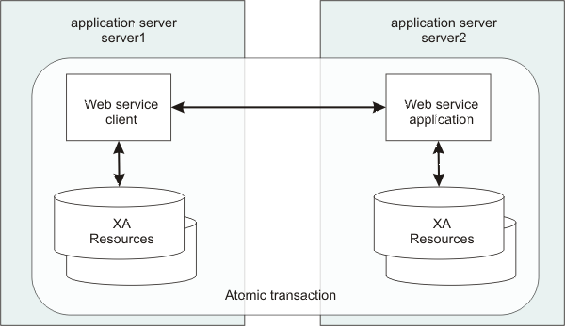
Need ACID Transactions over a service? you’re going to need SOAP.
In computer science, ACID (Atomicity, Consistency, Isolation, Durability) is a set of properties of database transactions intended to guarantee validity even in the event of errors, failures etc.
While REST supports transactions, it isn’t as comprehensive and isn’t ACID compliant. The good news is ACID transactions rarely make sense.
REST is limited by HTTP itself which can’t provide two-phase commit across distributed transactional resources. SOAP can via WS-AtomicTransaction. While internet apps usually don’t need this, enterprise-grade apps may.
But, Distributed transactions are an antipattern. Some say they should never be used. It’s even becoming a serious headhache in microservices.
Distributed transactions destroy your scalability, and they force you to give up either availability or network fault tolerance. The CAP Theorem also named Brewer’s theorem after computer scientist Eric Brewer states:
It is impossible for a distributed data store to simultaneously provide more than two out of the following three guarantees:
- Consistency: Every read receives the most recent write or an error,
- Availability: Every request receives a (non-error) response – without guarantee that it contains the most recent write,
- Partition Tolerance: The system continues to operate despite an arbitrary number of messages being dropped (or delayed) by the network between nodes.
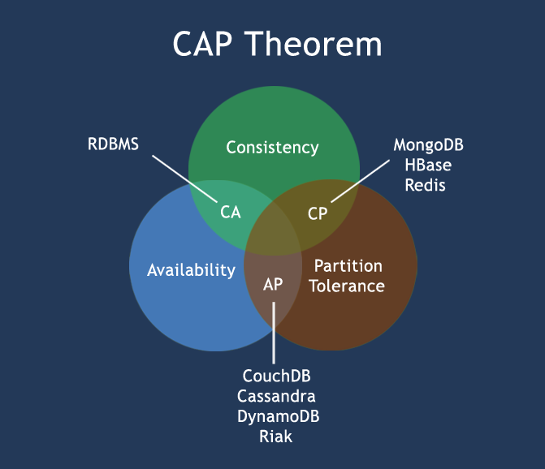
Use compensating transactions instead. If consistency is needed, define a single source of truth and do ACID transactions within it.

WS-ReliableMessaging
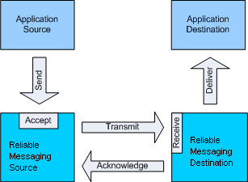
WS-ReliableMessaging describes a protocol that allows SOAP messages to be reliably delivered between distributed applications in the presence of software component, system, or network failures.
Rest doesn’t have any retry protocol. (although you can implement your own on top of it) SOAP has successful/retry logic built in and provides end-to-end reliability even through SOAP intermediaries.
But, WS-ReliableMessaging guarantees only reliable transport, not reliable application processing. It makes it unsuitable for reliable messaging. Nobody Needs Reliable Messaging explains this in great details.
The RESTful way to do reliable messaging is to use idempotency. The solution is to make sure repeated calls to a single service doesn’t affect the result more than once.

Use-Cases
Let’s take some real-world use-cases and see which protocol is best suited for each:
User-Case | SOAP | REST
Public Facing API |  | X | Simplicity is one of the strongest reasons to opt for REST.
High Throughput API |  | X | Rest is preferred for performance reason (lot of requests)
Payment System | X |  | Soap is preferred for security reasons
Mobile Application |  | X | REST with Json is the standard as of now
It’s not a coincidence that most new APIs are built around Rest and Json. Frontends are mostly written in Javascript now: this language has native support for Json parsing and HTTP requests.

Useful Resources
Here are some services which can help you to try out both SOAP and REST services:
- HTTPBin: very simple Rest APIs with most common use-cases,
- WebServiceX: Free SOAP Services (with their WSDL),

